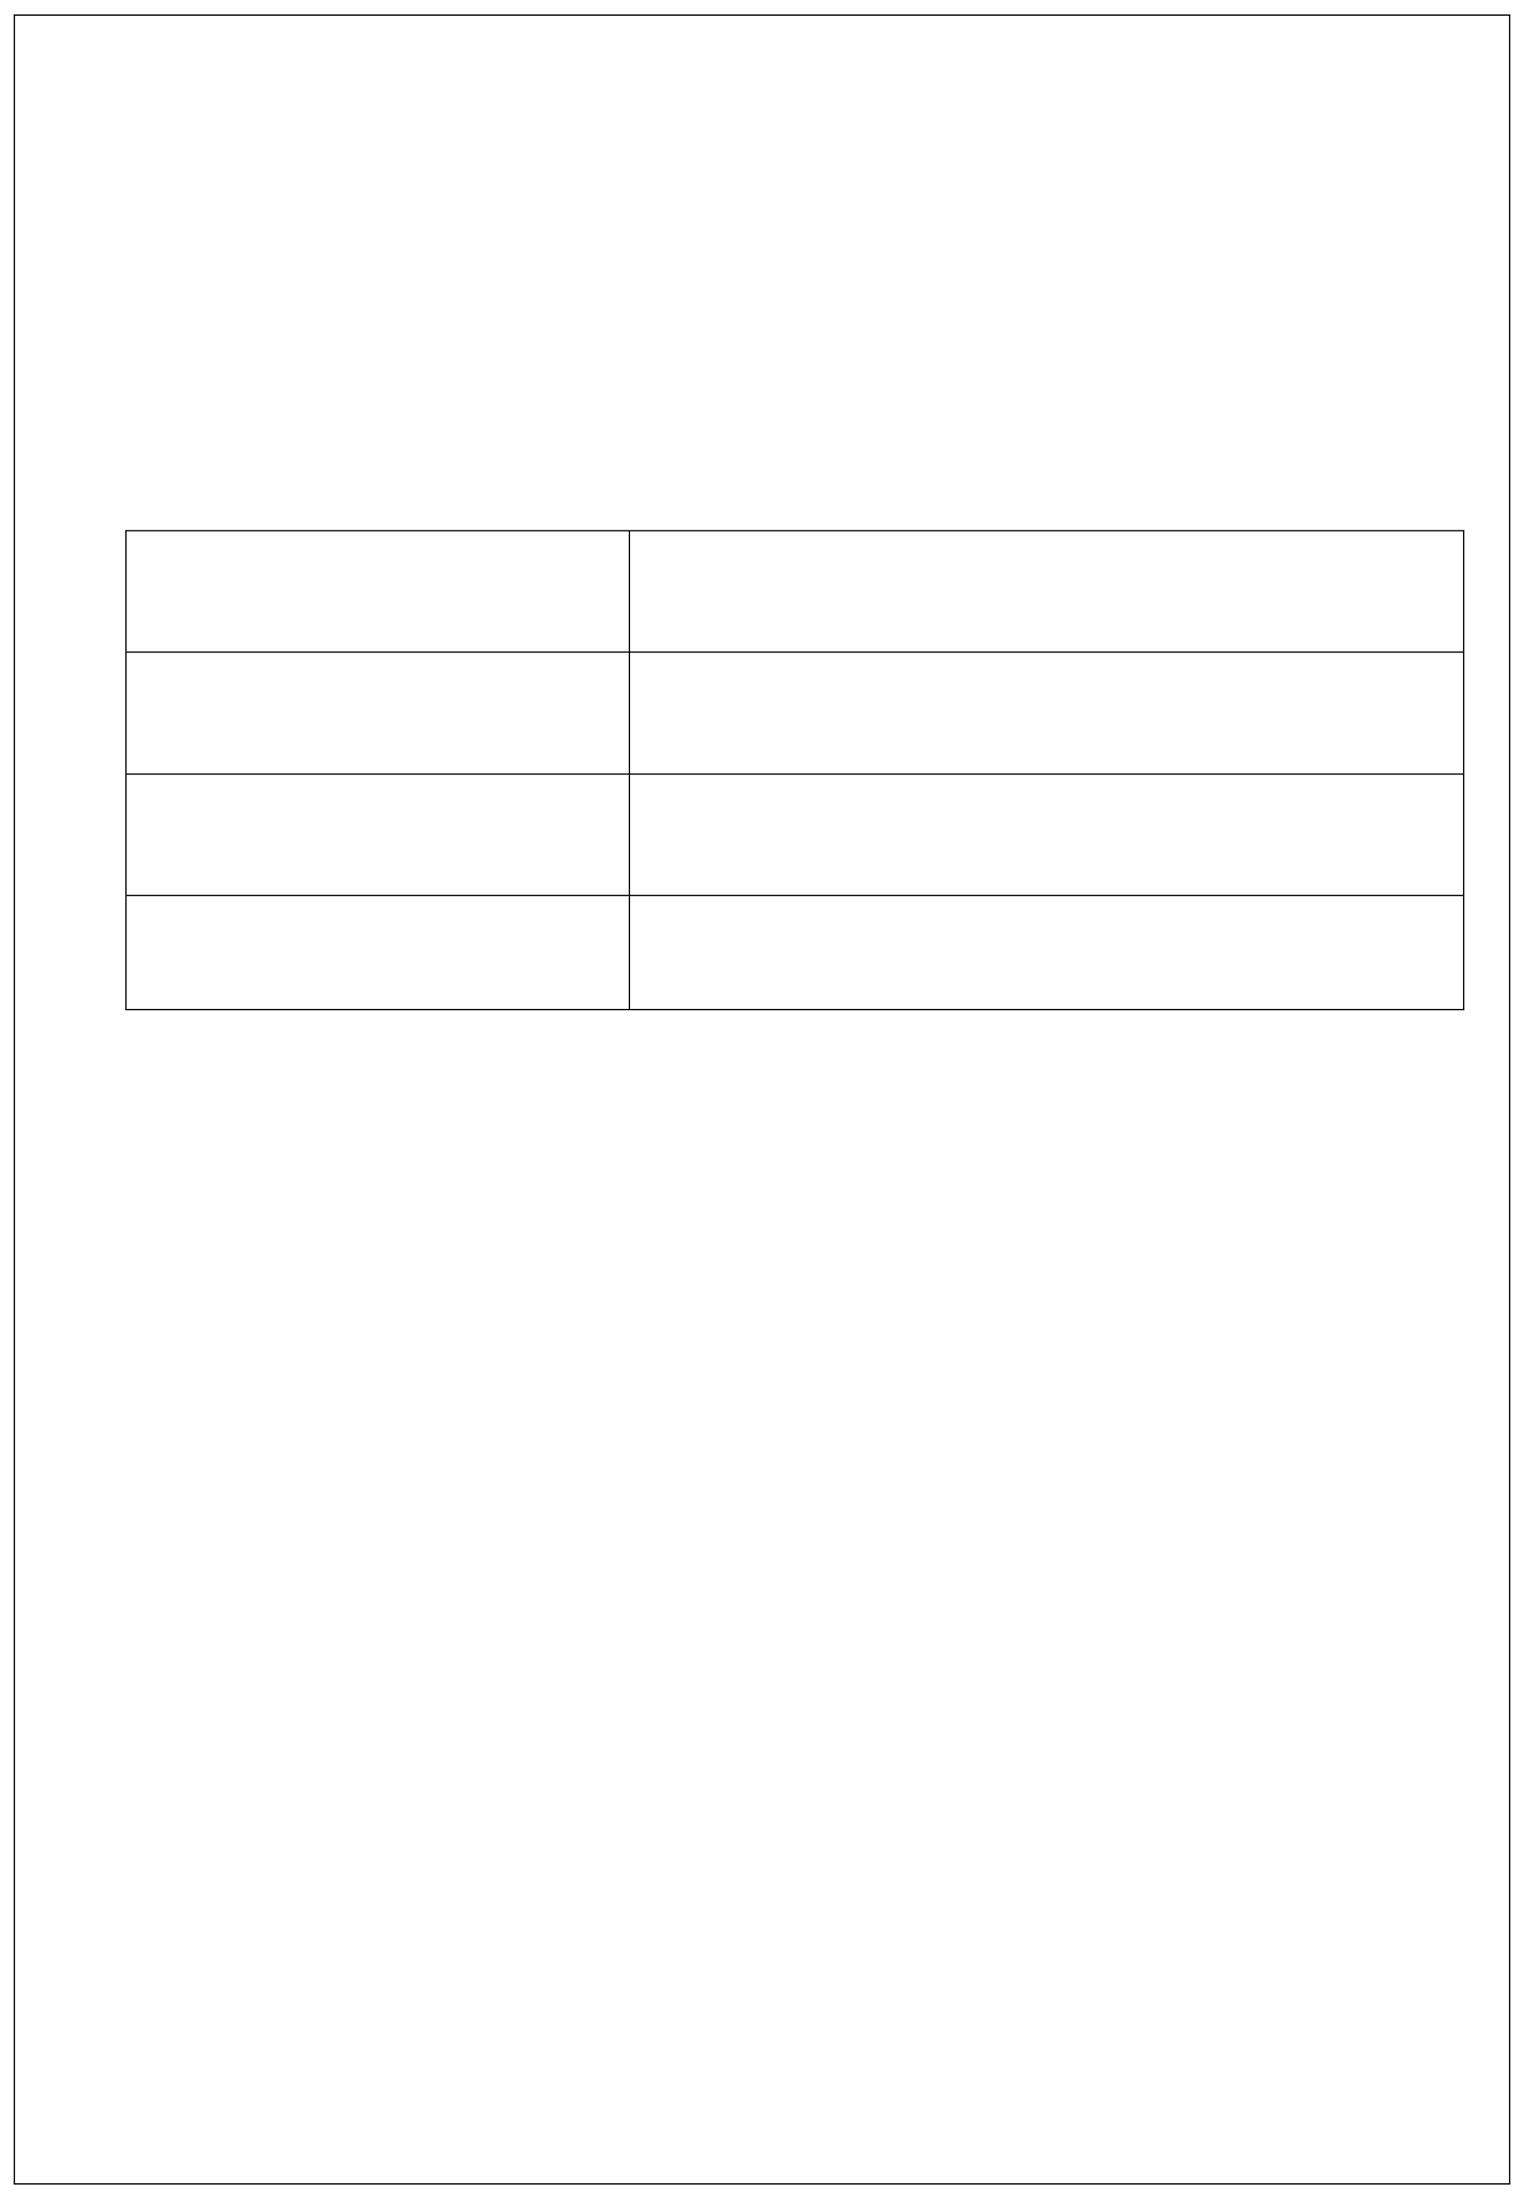
Public Camping Form
(Not for Traders or Exhibitors)
CAMPING IS AVAILABLE WEDNESDAY TO MONDAY
Every entry will receive 2 Adult wristbands, and 1 vehicle pass which must be
Worn and displayed at all times. Any extra wristbands or vehicle passes will be charged at £5 each. All children under 16 £1 per person

Camping Weekend Pass
1 Vehicle And 2 Adult Passes (Charged at £50 for the weekend) Extra Vehicle Passes:
(Charged at £5 each)

Extra Adult Passes: (Charged at £5 each)

Total: £

Please make cheques payable to Upper Test Valley Vintage Club.

Closing Date for entries: 1st August 2026
Entries accepted after this date will not be included in the Rally program. For any further information please contact Rally Chairman Andy Knight on 07533 726670 or E-mail: longstockrally@outlook.com
Visit
www.Longstockrally.co.uk

PLEASE SEND AN A5 STAMPED ADDRESSED ENVELOPE WITH YOUR ENTRY.

